Patient Information
Breathlessness
__________________________________________________________________________________
Factsheet 4: Positions to ease breathlessness
This information is designed to help you manage your stable long-term breathlessness. If your breathing is getting worse, or if your breathlessness is a new feeling, it is important to seek medical advice from your GP.

When to use
These positions may help you to ease your breathlessness at rest and after activity. The most commonly used positions are shown however you may find other positions that are helpful that are not shown. Experiment and modify different positions until you find what works best for you.
How positioning helps to ease breathlessness
The positions in this leaflet place the arms so the breathing accessory muscles are in a better position to help with breathing. Leaning forward may also improve the movement of your diaphragm, the main muscle of breathing. See Factsheet 3 for more information on muscles of breathing.
Resting positions
The following positions may help if you are breathless at rest, or if you are feeling very tired or exhausted.
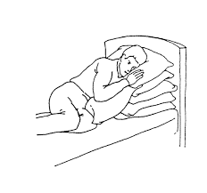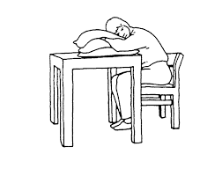
Make sure you are fully over on Relax down onto the pillows as
your side. Resting your upper much as possible. Having your
arm on a pillow may also help. legs apart may also help.

Positions to ease breathlessness following activity
The following positions may help to ease breathlessness after you have been active. With all positions, try to relax the hands, wrists, shoulders, neck and jaw as much as possible.
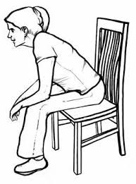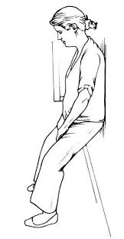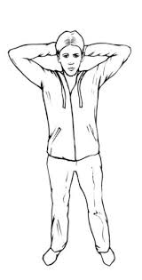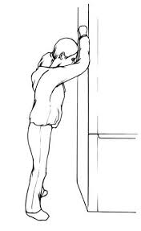
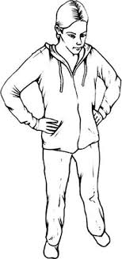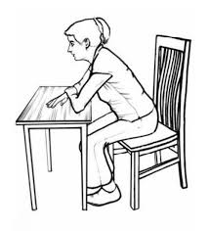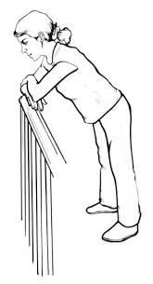

There is no one position which suits everyone. Experiment with different positions and find what works best for you.

Use of walking aids
Some people might notice that they are able to walk further and feel less breathless when pushing a supermarket trolley around the shop. Pushing the trolley enables you to maintain a ‘forward lean position of ease’ while walking.
In a similar way, using a walking frame may enable you to walk further and feel less breathless, as well as providing a portable leaning post when you wish to stop to rest. A walking stick can also provide a portable leaning post.
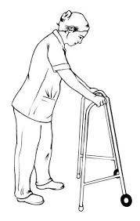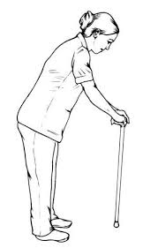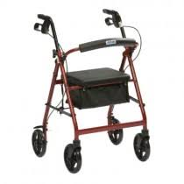
When walking outdoors people often prefer to use a three- or four-wheeled walker.
Some walkers have a seat so that you can sit down to rest. Others may have a useful storage compartment.

Contacts/further information
Other factsheets in this series will go through these techniques in more detail.
If you would like this information in large print, please contact Teesside Hospice on 01642 811060.
Acknowledgement
This document has been reproduced and adapted from the patient information leaflets developed by the Cambridge Breathlessness Intervention Service, Cambridge University Hospitals NHS Foundation Trust / Addenbrooke’s Hospital, with kind permission.

Developed 11/2022
Review 11/2024

