Patient Information
Breathlessness __________________________________________________________________________________
Factsheet 3: Breathing techniques to ease breathlessness
This information is designed to help you manage your stable long-term breathlessness. If your breathing is getting worse, or if your breathlessness is a new feeling, it is important to seek medical advice from your GP.
Muscles involved in breathing
The diaphragm
The main muscle of breathing is the diaphragm. This is a large dome shaped muscle covering the base of your rib cage. As you breathe in, it flattens to help draw air into your lungs and your tummy will rise. When you breathe out, it relaxes and returns to its natural dome shape, allowing your tummy to rest back in. The diaphragm is a very efficient muscle and does not tire easily.
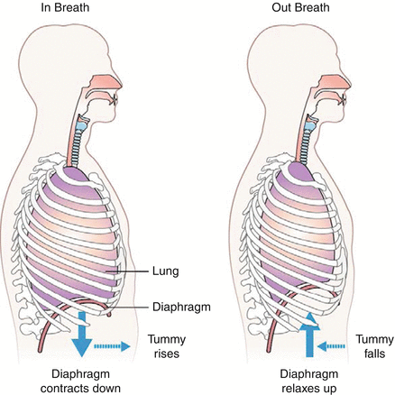
Breathing accessory muscles
There are many muscles around your neck, upper chest, and shoulders with the primary role of moving your neck and arms. When you are breathless, these muscles can pull on the ribs to help with the work of breathing. These muscles are called breathing accessory muscles.
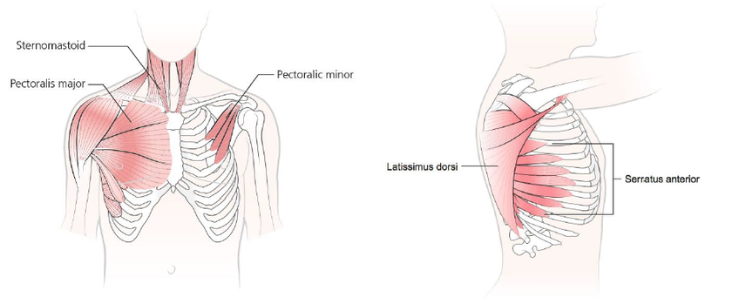

It is normal to use these muscles for short periods of time when breathless, but they are not designed to help with breathing for prolonged periods. They require extra energy and effort to use and get tired far quicker than the diaphragm. When used excessively, these muscles can unhelpfully focus the breathing to the upper chest, making the breathing pattern inefficient. With continued overuse they may become tight, sore, and stiff.
It is normal to use your breathing accessory muscles when breathless, but it is also important to relax and ‘switch them off’ once the breathlessness episode has passed. Try to focus your breathing movement on your tummy (diaphragm) as much as possible and keep your accessory breathing muscles in reserve.

Breathing techniques
Relaxed tummy breathing
When to use
Relaxed tummy breathing may help you to recover more quickly from breathlessness after activity. It may also help your breathing to settle if you feel panicky. You may wish to use this breathing technique together with a hand-held fan (Factsheet 2) and a position to ease breathlessness (Factsheet 4).
How it Works
Relaxed tummy breathing is sometimes known as breathing control. The aim is to move from fast’ upper chest breathing to relaxed, slow tummy breathing. This breathing technique helps to focus on breathing from your diaphragm with the upper chest relaxed. This will help to make your breathing as efficient as possible.
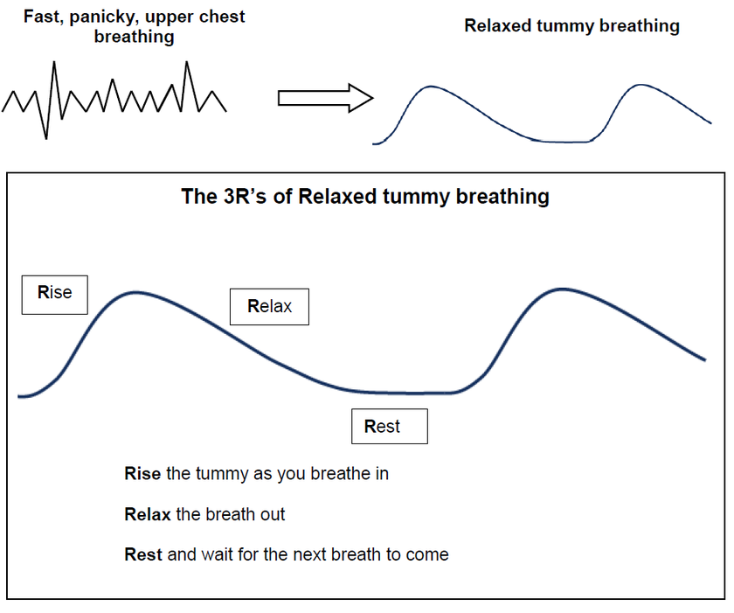

Breathing from the tummy does often not come naturally and will need practise. Try to practise when you are not breathless for 10 minutes at a time, at least twice a day.
Before you start, make sure you are in a comfortable position with your head and back supported and your shoulders and upper chest relaxed. Place one hand on your tummy. Feel the tummy rise as you breathe in and relax down as you breathe out. Breathe gently when practising; there should only be a slight movement of your tummy at rest.

‘Breathe low and slow, relax, let go’
If you have a tendency to breathe with small, fast breaths from the top of your chest you may find taking slower, deeper breaths from your tummy helps to ease breathlessness.

Breathe a rectangle
When practising relaxed breathing, imagine the shape of a rectangle. Follow the sides of the rectangle with your eyes as you tummy breathe. Gradually slow the speed at which your eyes move around the edge of the shape to slow your breathing. Wherever you are, there is often a rectangle to be seen, for example a TV, computer screen, a window, or a picture on the wall.
Breathe Out

Breathe In
Breathe In

Breathe Out

Recovery Breathing
When to Use
Use recovery breathing when you feel extremely breathless or panicky and you are unable to use relaxed tummy breathing.
How it Works
Recovery breathing allows more time for the air to leave your lungs as you breathe out, therefore creating more room for the next breath in. The aim of recovery breathing is to calm your breathing until you can breathe more smoothly and quietly from your tummy again.
The 3F’s of Recovery Breathing
Fan
Forward lean position
Focus on long or relaxed breaths out

People with COPD, emphysema or asthma may prefer long breaths out, perhaps through pursed lips. People with other conditions may find relaxed breaths out suit them better.

Pursed lips breathing
Some people find breathing in through the nose and out through narrowed lips helps to ease their breathlessness. This technique tends to help people who have conditions such as chronic obstructive pulmonary disease (COPD) or emphysema. People who find this technique beneficial often use it without realising they are doing it.
Pursed lips breathing helps to support the airways to open therefore allowing the air to leave the lungs more easily. This creates more room for the next breath in. You can use pursed lips breathing at the same time as relaxed tummy breathing or recovery breathing and in a position of ease.
General advice
- Avoid breath holding during activities e.g., climbing stairs or bending
- Try to ‘blow as you go,’ which means breathing out on effort, e.g., blow out when bending, lifting, reaching, or standing up from a chair
- Try to avoid rushing
- Try pacing your breathing with your steps e.g., take a breath in and out on each step when climbing the stairs.

Contacts/further information
Other factsheets in this series will go through these techniques in more detail.
If you would like this information in large print, please contact Teesside Hospice on 01642 811060.

Acknowledgement
This document has been reproduced and adapted from the patient information leaflets developed by the Cambridge Breathlessness Intervention Service, Cambridge University Hospitals NHS Foundation Trust / Addenbrooke’s Hospital, with kind permission.

Developed 11/2022
Review 11/2024

