Patient Information
Breathlessness __________________________________________________________________________________
Factsheet 2: Hand-held Fan
This information is designed to help you manage your stable long-term breathlessness. If your breathing is getting worse, or if your breathlessness is a new feeling, it is important to seek medical advice from your GP.
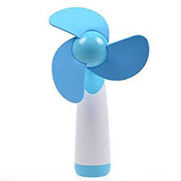

Will using a fan help my breathlessness?
When breathless you may find that you go to open a door or a window to get some ‘fresh air’. Similarly, a cool draught of air from a hand held fan can reduce the feeling of breathlessness.
The following may also be useful to help ease breathlessness:
- A cool flannel or cool water mist spray to the face
- Opening windows, for example in a car
- Desktop or floor standing fans
How does facial cooling ease breathlessness?
Research has shown that cooling the face with a fan is effective at reducing breathlessness. It is thought that cooling the cheeks, nose and mouth areas sends a message to the brain which reduces the feeling of breathlessness.
How should I use the hand-held fan?
- Adopt a comfortable position that eases your breathlessness.
- Hold the fan approximately 15 centimetres or 6 inches away from your face.
- Aim the draught of air towards your face and move the fan slowly from side to side so that the draught covers the nose, mouth and sides of the cheeks.
- Use it until you feel your breathing ease.
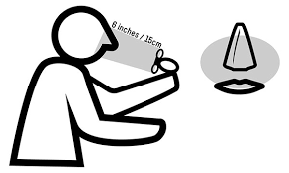
Fans with three or more rotating blades seem to be more effective as the airflow is stronger.
The fan can be used at the same time as nasal oxygen. People using face mask oxygen have found that cooling the cheeks, neck and upper chest with the fan helps to ease their breathing.
When should I use the fan?
You can use the fan whenever you feel breathless. Keep the fan in your pocket or bag when out and about so you have it to hand when needed. Keep a hand-held fan by your bedside so it is in reach if you wake at night. You may find it useful to keep several fans around your home in helpful places for example, in the bathroom or next to your chair.
You may find it helpful to use the fan with other breathlessness management techniques such as positioning, breathing techniques and relaxation.
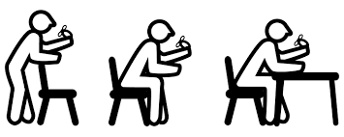

Reference
Galbraith S, Fagan P, Perkins P, Lynch A & Booth S (2010) Does the use of a hand-held fan improve chronic dyspnoea? A randomised, controlled, crossover trial. Journal of Pain and Symptom Management Vol 39, Issue 5, p831 – 838.

Contacts / Further Information
Other factsheets in this series will go through these techniques in more detail.
If you would like this information in large print, please contact Teesside Hospice on 01642 811060.

Acknowledgement
This document has been reproduced and adapted from the patient information leaflets developed by the Cambridge Breathlessness Intervention Service, Cambridge University Hospitals NHS Foundation Trust / Addenbrooke’s Hospital, with kind permission.

Developed 11/2022
Review 11/2024

