Teesside Hospice actions against UN 2030 Agenda as at February 2024

 | Environmental | Governance | Social
No Poverty  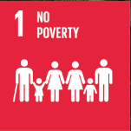 | Create paid employment opportunities for the wider community | Hospice services provided at no cost to individuals | Advice and assistance applying for benefits and grants
Zero Hunger  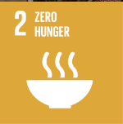 | Food waste carefully managed  Ingredients ethically sourced | Specialist diet and meal planning to support good health | Reuse excess stock donated from supermarkets
Good Health and Wellbeing  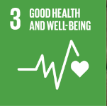 | Robust recycling and food waste schemes across all hospice operations  Play an active role in wider public health messages and promotion  No smoking on the hospice site * | Support, investment and advice for whole team  Embracing new solutions that enhance wellbeing  Ensuring equal access and support to all communities  Maintaining external validation and assessment of our activities | Making the hospice environment a pleasant place to work and stay  Facilitate and support corporate volunteering  Quality volunteering opportunities  Hospice activities that also build social and friendship networks  Cycle to work scheme available to all staff
Quality Education  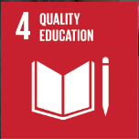 | Reaching out beyond the hospice to share our specialist knowledge and skill | Dedicated resources that are embedded within core strategy and objectives  Robust and useful mandatory training for whole team | Sharing our resources and knowledge with the wider community
Gender Equality  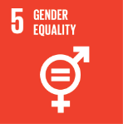 | Connecting with individual groups within our community to learn and share | Clear and regularly reviewed commitment from board on their approach to EDI  Campaigning for the end to post code lottery of hospice care | Playing an active role in awareness raising and supporting marginalised groups
Clean Water and Sanitation  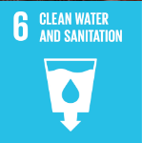 | Waste management policies that avoid contamination  Use of water butts and recycling to reduce use of clean water | Routine training and education on hand hygiene  Comprehensive maintenance schedules of water and sanitation systems | Education and signage that reduces waste
Affordable and Clean Energy  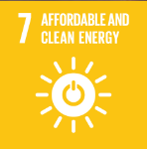 | Energy efficiency schemes implemented and underway  Aspirations to introduce solar energy and electrical car charging points | Many energy efficiency schemes already completed or underway  Resources available to develop and implement further energy efficiency schemes | Developing relationships that help us learn and expand our clean and efficient energy use
Decent Work and Economic Growth  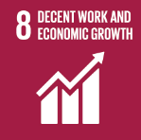 | Volunteering and placement programmes create learning and employment opportunities  Employer of over 150 people  Long term plans to grow income and create more paid opportunities | Progressive, supporting policies that promote wellbeing and inclusion  Achievement of Better Health at Work standards  Salary scales benchmarked to avoid exploitation | Access to wellbeing support and activities that encourage good health at work  Campaigning and activism to facilitate fairer funding for delivering mandated NHS services
Industry, Innovation and Infrastructure  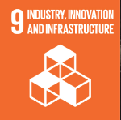 | Investing in hospice estate to maintain high standards  Introducing digital tools and solutions across all functions | Using skills audits to ensure Board of Trustees include relevant skills and knowledge  Designating funds that can be used to develop new initiatives | Using digital channels and technology to improve engagement with supporters and beneficiaries
Reduced Inequalities  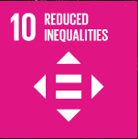 | Removing physical barriers where possible and purchasing specialist equipment to reduce inequalities in care | Clear EDI statement of intent from Board of Trustees  Organisation wide training on EDI and equality of opportunity | Delivering core hospice services at no cost to beneficiaries  Outreach work to mitigate geographic inequalities  Collaboration with community groups working with under-represented people
Sustainable Cities and Communities  Responsible Consumption and Production  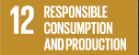  Climate Action  Life on Land | Hospice shops make significant contribution locally to recycling of used clothes and other goods  Ongoing programme to minimise use of energy consumption | Clear policies on recycling and waste disposal  Ambitions to transition to electric and lower emission transport in renewal plans  Support cycle to work scheme and use of most carbon neutral transport  Aspiring to maintain an understanding of current carbon footprint | Create opportunities for communities across Teesside to recycle good that might otherwise go to landfill
Peace, Justice and Strong Institutions | Zero tolerance of violence  Values that promote honesty and transparency | Robust internal governance arrangement  Independent assurance through regulators and auditors  Shared objectives that tie into wider community needs | Advocacy and campaigning for those less able to speak for themselves  Seeking and learning from feedback on performance and impact
Partnerships for the Goals  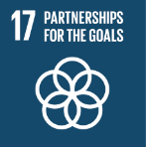 | Share site and resources with other organisations and partners | Shared understanding of our purpose and role in the system  Play an active role in collaborative projects and multi-disciplinary working | Playing an active role in developing wider health/social policies and impact  Shared values that recognise the benefits partnerships bring to our work

